**Ticket Out The Door**

Is war inevitable?

Yes No Unsure

I’ve learned that:

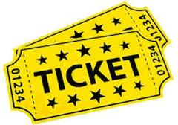

**Ticket Out The Door**

Is war inevitable?

Yes No Unsure

I’ve learned that:



**Ticket Out The Door**

Is war inevitable?

Yes No Unsure

I’ve learned that:



**Ticket Out The Door**

Is war inevitable?

Yes No Unsure

I’ve learned that:

