EVALUATING TWO ICONIC PHOTOS

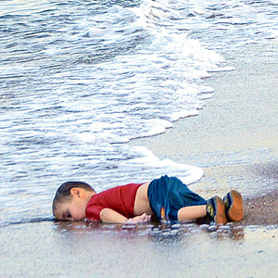
His name was Alan Kurdi. He was 3 years old, from Syria, drowned in 2015 while escaping the civil war in Syria with his family and washed up on a beach in Turkey.
Credit/Source: Accessed here December 2015
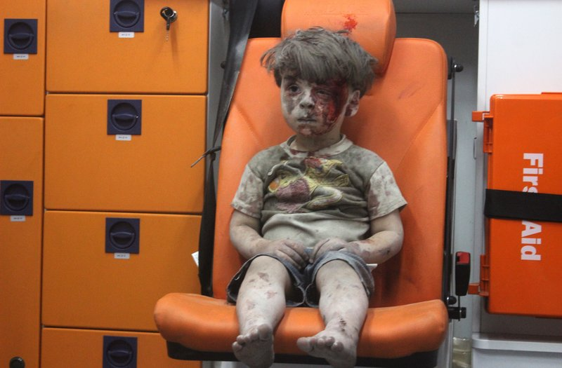
His name is Omran Daqueesh and he is 5 years old. He sits in an ambulance after being pulled out of a building hit by an airstrike in Aleppo, Syria in 2016.
Credit/Source: Accessed here August 2016
What do each of these photos say about the war in Syria?
Which is more powerful? Why?

