A Closer Look:
Activities Related to the Individuals and Images in this Gallery

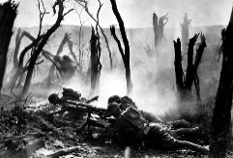 | A. WW I  - Write a review of this BBC documentary on boy soldiers.  - Create a Question Tree answering as many WHAT, WHY, WHO, WHEN, WHERE, HOW questions as possible. Examples: What are the reasons for children volunteering? Why did the government encourage this? Who are the people affected by this issue? When did this become political? etc.
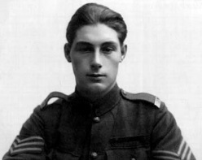 | B. Tommy Rickets  - Research reasons why men and boys enlisted in WW I.  - Write a letter, monologue or a two-person dialogue in which Tommy argues with his mother about enlisting. Present this dialogue to the class.  - Research Tommy’s experiences for which he received awards. Then write a diary entry in which he describes his actions in a battle.
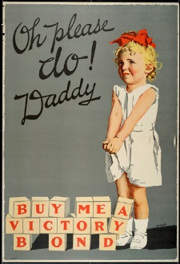 | C. Faith Beny  - Research the purpose and history of Victory War Bonds.  - Write and perform a dialogue in which Faith Beny is interviewed about the reasons why a father should buy a Victory Bond for his daughter. The interviewer should then try to learn what such a young girl knows and believes about war.  - Write an opinion piece or editorial either in favour of or opposed on the use of children to promote the sales of Victory War Bonds.  - Write or orally present an analysis of this poster. Learn how to do this on Wikihow: How to analyse political cartoons.
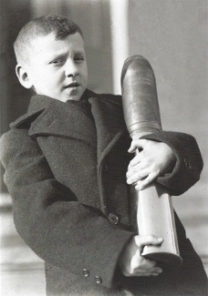 | D. Norman Jones  - Write a newspaper article to accompany this photo that speaks about the role of children “doing their bit” in WW I.  - Write an opinion piece or editorial on the use of Norman Jones in this photo. Why do you think that a child is used in this photo rather than an adult? Do you think it is appropriate for a child to be carrying a bomb?  - Create a political cartoon inspired by this photo. Checkout Wikihow: – How to make a political cartoon.  - Write or orally present an analysis of this photo. Use the Photo Analysis worksheet found in Educational Activities for Iconic Photos.
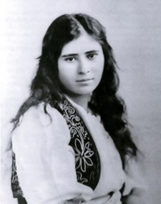 | E. Aurora Mardiganian  Note: The Armenian Genocide Museum in Yerevan, Armenia includes an exhibit on Aurora Mardiganian, her memoirs and the film about her experiences.  - Visit the museum website and create a pamphlet or 3-fold brochure promoting the museum, with space devoted to Mardiganian.  - Create a 30 sec. promotional video for the museum, specifically the reasons why the Armenian Genocide should be recognized.  - Write a review of the Beyonce video, Never Forget. For additional help, consult Wikihow.  - Group discussion: What message does this video provide about the Armenian Genocide? Should more celebrities speak out about war?  Additional Resources On The Armenian Genocide:  Genocide in Armenia  What is Genocide?
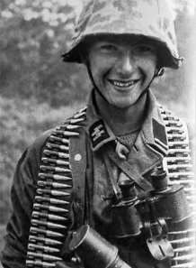 | F. Bill Edwardes  - Step inside Bill Edwardes’ world view:  Write three diary entries or monologues in which you, as Bill, describe how you felt when you first enlisted, how you felt on a particularly difficult day as a stretcher-bearer, and how the war experiences have changed you. Write this from the perspective of a teenager, which Bill was at the time. Share your diary entries or perform your monologues.  - Write a poem or song describing a scary moment on the battlefield.  - Create at least three panels of a graphic novel to illustrate some of Bill’s experiences. Note: You may have to make these up, but can do so by reading/researching about the work of medical assistants.  - Research how triage was conducted in WW I. Write an advice manual for newcomers/recruits outlining the proper procedures to be followed by stretcher bearers.
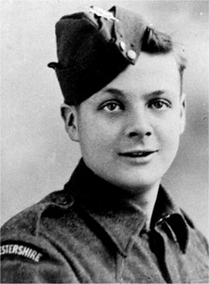 | G. Hitler Youth  - View these YouTube videos:  Hitler’s Children: Seduction (Episode 1, 48 mins):  Hitler’s Children: War (Episode 4, 48 mins)  - Write a five paragraph essay on the Hitler Youth based on what you learned from these videos. Identify three significant points and refer to them in your thesis.  - Research Hitler Youth camps:  - Prepare a Youth Camp schedule for a week.  - Create a Hitler Youth Camp poster designed to attract 14 year olds.  - Write a poem or song capturing the enthusiasm of a member of Hitler Youth.
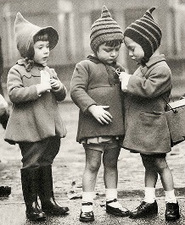 | - Child Evacuees WW II  - Create two posters promoting Kindertransport to parents, and Operation Pied Piper to prospective foster parents. Make sure that the different goals and destinations are obvious. Use emotional appeal in the art and language.  - Research and write an opinion paper or five paragraph essay on Operation Pied Piper, which moved approximately two million children in three days. Some questions to answer: Where did the children go? How were they placed? How were they treated? In your opinion, was this a good idea?  - Create and deliver a dialogue between two parents debating whether to send their children out of the country for safety.  - With another student or in teams of two, perform a debate on the topic, “Be it resolved that in all wars, wherever possible, children should be evacuated to safety.”  - Create a poem, song, monologue or diary entry from the point of view of a child evacuee.  - Create three panels of a graphic novel depicting an aspect of either Kindertransport or Operation Pied Piper.  - Write an analysis of this photo. Use the Photo Analysis worksheet 1.1 found in Educational Activities for Iconic Photos.  Additional Resources:  Children from Overseas NFB, 1940, 10 min. propaganda  No Time To Wave Goodbye Ben Wicks tells of the experiences of 3.5 million child evacuees.
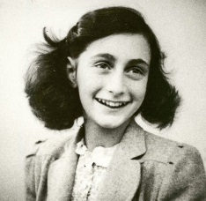 | - Anne Frank  - Divide the class up into small groups. Have each group read the play, The Diary of Anne Frank. Through consensus, each group should decide on the most important scene and to develop a performance of this part. They should plan how to perform it: Who will play particular roles? Do you need props? Practise!!! Each group should perform its scene to the class. To introduce their performance, group members should explain what has gone before so that their audience can understand what they are going to see. Plan questions for discussion after your performance.  - Create a model of the Secret Annex.  - Research Bergen-Belsen Concentration Camp and create a multi-media presentation that describes different aspects of the camp. Some topics could include: 1) the origins and dates the camp operated, including the number of men, women and children who were sent to the camp 2) the overall operations; how people were sent to the camp 3) the background of the people who were sent to the camps (not just Jewish people, but also handicapped, Roma and homosexuals) 4) the daily operations 5) the number of people who were killed in the camp and 6) the rescue mission and the dismantling of this and other extermination camps.  Additional Resources on the Holocaust:  I Never Saw Another Butterfly by Hana Volakova Poems and pictures drawn by child prisoners in Terezin Concentration Camp.  The Butterfly Project is a unit based on this book.  Lesson Plans  “Beyond Anne Frank: Other Holocaust-Era Diaries”  The Book of Aron, a novel, Jim Shepard  Film: The Boy in the Stripped Pajamas, 1:34 Roger Ebert’s review.
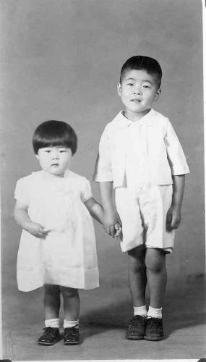 | - Joy Kogawa  - Find a recent photo of Joy Kogawa. Read about her life in The Canadian Encyclopedia.  - Write two letters to the editor, or two editorials, one supporting the internment of the Japanese Canadians, the other one opposed.  - Read and discuss two poems by Joy Kogawa. What Do I Remember of the Evacuation? Where There’s a Wall  - Read her children’s book, Naomi’s Road (120 pages) about children who are separated from their parents and sent to a Japanese internment camp. Plan and deliver a lesson to an elementary class based on this book.  - Read Obasan by Joy Kogawa. (320 pages) Then make a promotional video book trailer.  - Design a new set of book covers, updated for students your age.  - Write and deliver a monologue in which the main character reflects on the impact of a significant incident in the book.  - Create three pages of a graphic novel in which you explore a powerful incident from the book.  - Visit the website of Historic Joy Kogawa House  - Learn about the home in which she lived before her family was forced to evacuate and about the Writer Residencies which are offered to qualifying Canadian writers.  - Create a brochure to inform writers about this opportunity and the application process.  Additional Resources: Internment of Japanese Canadians  Hotel on the Corner of Bitter and Sweet, Jamie Ford (290 pages)  Minoru: Memory of Exile Michael Fukushima, 1992, Award-winning National Film Board movie (19 min)  Some questions to guide the viewing of this film:  - What is the irony in Prime Minister Mackenzie King’s statement about democracy?  - What did the internship and deportation cause Minoru to lose?  - Write a review of this animated video.  - With a partner, write and perform an interview with Minoru Fukushima about his life.  - Write two poems: one from the point of view of Minoru Fukushima, and one from the point of view of his son, Michael, the creator of this film. Focus on their feelings about Canada.
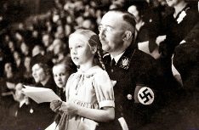 | - Gudrun Himmler  - Investigate Heinrich Himmler’s position and the organization of “The Final Solution”. Investigate how the Dachau Concentration Camp and other extermination camps were organized.  - Write a diary entry from the perspective of Gudrun describing the buildings when she visited Dachau with her father. Compare this to what she said about this visit.  - Write and deliver a monologue in which an adult Gudrun Himmler defends her father and his actions. Compare this to her views (available on the Internet).
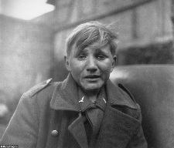 | - Hans-Georg Henke  - Write two diary entries: 1) Hans-Georg ponders his parents’ deaths and his reasons for joining the German Forces and 2) His fear when he was captured by the Allied Forces.  - Write a report as the Allied Forces commanding officer, who describes taking Hans-Georg prisoner, the circumstances, how he looked, and why he decided to let him go. (Note: Information on this event is available on the Internet).  - Write or orally present an analysis of this photo. Use the Photo Analysis worksheet found in Educational Activities for Iconic Photos 1.1.  - Create an interview with Hans-Georg after he returned home, imagining what he was thinking and his plans for the future.  - Write a poem or song in which you capture how Hans-Georg felt the day he was captured.
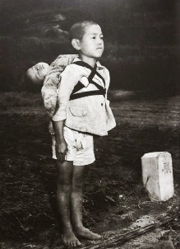 | - Japanese Boy, Nagasaki, 1945  - Write a newspaper report to accompany this photo providing information on the bombing of Nagasaki and Hiroshima and the impact this had on the Japanese people living in this area.  - Write or present an analysis of this photo. Use the Photo Analysis worksheet found in Educational Activities for Iconic Photos 1.1.  - Write a poem about this incident.  - Watch the animated movie, Grave of the Fireflies, a1988 Japanese animated film about a brother and sister trying to survive in Japan in WW II. Film critic Roger Ebert says Grave of the Fireflies belongs on any list of the greatest war films ever made.  - Write a review perhaps using advice from Wikihow and select a scene to show to the class, explaining why you chose it.
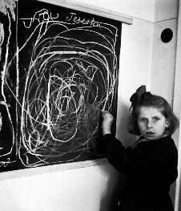 | - Tereszka  - Read David Seymour’s account of his visit to the Polish orphanage and his photo of Tereszka. Imagine that you are a child psychiatrist observing Tereszka. Write about her in your professional journal and suggest what kind of treatments you are considering.  - Imagine that a new student comes to your school who has lived through a traumatic war experience. How would you assist her?  - Write or present an analysis of this photo. Use the Photo Analysis worksheet found in Educational Activities for Iconic Photos 1.1.  - View the YouTube video, Children of the Holocaust. This film includes photographs, text and music by Radiohead and Coldplay. Note that some of these images are very graphic. Write or present a review of the video.  - Write and perform a monologue by Tereszka when she is asked to describe what happened to her.
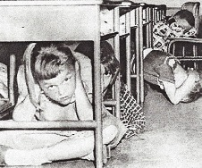 | - “Duck and Cover”  - Find images of the destruction caused by test bombings of nuclear bombs. Compare this with the “Duck and Cover” educational film. Write an editorial or opinion essay in which you discuss the intention and usefulness of this film.  - Watch the Academy Award winning documentary, If You Love This Planet for an overview of the devastation of nuclear weapons and for a glimpse into the fear felt during the Cold war. 1982, 26 min.  - Create a political cartoon exposing the irony of the "Duck and Cover" film. You might get some advice from Wikihow – How to create a political cartoon. Perhaps get some inspiration from the satirical cartoons of Pawel Kuczynski.  - Write an ironic poem or song about this film.  - It’s 1951 and you have been hired to make a brochure providing step-by-step instructions for building a home fallout shelter to protect a family in case of nuclear war and a list of what supplies should be stocked. Visuals and information on air raid shelters are available on the Internet.
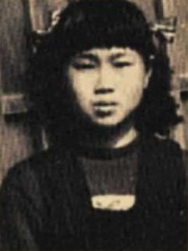 | - Sadako Sasaki  - With your teacher’s help, volunteer to give a presentation about Sadako Sasaki to an elementary school class. This could include a story-telling and a craft session to make paper cranes. Read Sadako and the Thousand Paper Cranes. Prepare to tell the story in a way that will appeal to the grade level that you will be visiting. Learn how to teach the students to make origami cranes. Be sure to practice both story-telling and instructions for crane making so that your lesson goes well. Bring enough origami paper with you and a needle and thread. String the students’ cranes on the thread and hang in their classroom.  - Read Sadako and the Thousand Paper Cranes and create a promotional video book trailer.  - Create new front and back covers for Sadako and the Thousand Paper Cranes to appeal to readers of your age.  - See a slide show about how to create a wall of art based on the book. Make your own wall of art.  - Go online to see the statue created to honour Sadako which stands in Hiroshima. Print a copy of it. Write a description of it that is accurate, so that when others hear your description they will be able to draw it. Conduct this experiment with students in your class standing with your back to them. When they are done, show them the photo of the statue. How good was your description?  - Write and / or perform a mock interview with Sadako’s friend and one of her parents about her life and death.  - Write a news article about either Sadako’s death or the creation of the Children’s Peace Monument in Hiroshima.  Additional Resources: Bombing of Hiroshima  Barefoot Generation (1983) "Hadashi no Gen” Animation, 14A , 83 min. A powerful statement against war, Barefoot Gen is a disturbing film about the effect of the atomic bomb on a boy's life and the lives of the Japanese people. If you don’t watch all of this excellent video as a class, take a look at the animation of:  - the bombing of Hiroshima at 40 mins: graphic and powerful  - the burning of the victims on funeral pyres at 1:25 mins.- reminiscent of the photo of the Japanese boy delivering his brother to the funeral pyre  - Learning activities related to this film:  - Make a chart of all the conflicts in the film, and to what extent they are resolved. (Person vs. self; person vs. nature; person vs. others; person vs. philosophies)  - Using clips from the video, demonstrate to your class evidence of these conflicts and use illustrations from the film to show to what extent these are resolved.  - Explain and illustrate the person growth of the different characters in this film. Illustrate this through clips. Study the depiction of eyes in this animation. Create a thesis about how eyes are depicted, and present supportive proof.  - What insight does this film provide about the abuse of vulnerable people? Look at the presentation of the wounded man who is helped by Gen and his brother.
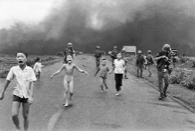 | - Kim Phuc, Vietnam  - Study this photo carefully. Use the worksheet on analyzing a photo found in the Educational Activities for Iconic Photos 1.1. Then watch a video to learn the realities of what happened before and after the photo was taken. Make a summary of this to share with the class as part of your photo analysis presentation.  - Learn about the Kim Foundation. Create a three- fold brochure or 30 second video to promote her foundation to young people.  - Research napalm and then write an opinion paper. Questions to explore: What is napalm and what does it do? How and why was it used in the Vietnam War? Is napalm used today? Include this information in your paper. Your thesis should reveal your views on napalm as a weapon of war.  - Create two pages of a graphic novel depicting part of Kim Phuc’s life.  - Learn all you can about Kim Phuc and deliver a story about her life without reading or using notes.
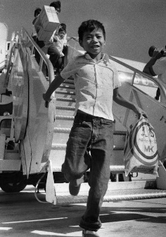 | - Canh Bui  - Read about Vietnamese refugees and Can Bui  - One-person task: Write an imagined interview with Canh Bui as he describes his flight from Vietnam to Canada.  - Small group activity: Write a dialogue in the form of an interview in which Canh’s story is shared on radio.  - Listen to a rebroadcast of CBC radio interviews about Canada’s welcome of Vietnamese refugees in 1976. Deliver a report on what you learned to your class including sound bites from the documentary.  - Research “Vietnamese Boat People Come to Canada”.  - Write a monologue, poem or diary entry from Canh Bui’s point of view describing what it may have been like to be a refugee fleeing Vietnam.  - Create a multi-media presentation to educate your classmates on this topic.  - Write or present a photo analysis using the worksheet in Educational Activities for Iconic Photos 1.1.  - Create three pages of a graphic novel depicting imagined incidents from Canh Bui’s life.
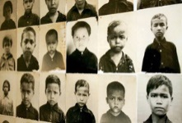 | - Child Victims of the Cambodian Genocide  - Study the faces in these photos. Select one. Imagine this child is your brother or sister who has gone missing. You fear that he/she has been sent to a work camp, but you don’t know. Write a description of your sibling to try to find him.  - Create a propaganda poster designed to brainwash children to show no emotion and to inform on their parents. Compare this with the strategies used by the Khmer Rouge during this time period.  - Research the Khmer Rouge and write an opinion essay explaining its goals, methods and results. Include these three topics in your thesis statement and be sure to include an opinion.  Additional Resources on the Cambodian Genocide:  Genocide in Cambodia
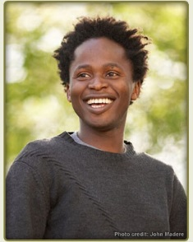 | - Ishmael Beah, Former Child Soldier  - Read A Long Way Gone: Memoirs of a child Soldier by Ishmael Beah. Read reviews and see videos of interviews with the author about his book, the writing process and the war in Sierra Leone.  - Research the RUF, the Revolutionary United Front. Compare and contrast this organization with the LRA, the Lord’s Resistance Army.  - Learn about the Forced Wife System in the Lord’s Resistance Army. Make a report to the class on what you’ve learned.  - Go to Child Soldiers. Make a report to your class on this organization to save and prevent the use of child soldiers.  - Research Sierra Leone’s Truth Commission, and its findings on child soldiers.  - Investigate different strategies used by UNICEF and other agencies in the demobilisation of child soldiers.  - Write a poem illustrating the contrasts in Ishmael’s life before and after he became a child soldier OR when he was a child soldier and now, when he is living safely.  Here is an example of a student poem using contrasts.  City Kid / Country Kid  A city kid has soul,  Dancing on the dirty steps,  “Kool and the Gang” blaring away,  A city kid has rock and roll.  A county kid has silence,  Trudging through new-fallen snow,  Flakes stinging his face.  A country kid has soul too.  Tim Daly, Putney School, Putney, USA, published in Powell, Brian. (1976) Their Own Special Shape. Don Mills: Collier Macmillan Canada, Ltd.
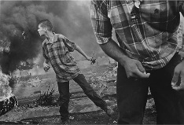 | - Ramallah, 2000  - Write or present an analysis of this photo using the worksheet in Educational Activities for Iconic Photos 1.1.  - Create a political poster based on this photo, perhaps using advice from WikiHow.  - Research the complexities of the Middle East conflict and write an opinion paper in which you explain why you favour either the two-state or one-state solution to this ongoing problem. Or organize a debate on this topic for your class.  - Create three pages of a graphic novel in which you explore this conflict from the point of view of a Palestinian or an Israeli.  - View this newscast about how both Palestinian and Israeli children are affected by the ongoing conflict.  - Write a review of each video and explain which one you think is more effective and why.  - Write a letter to the editor expressing concern about the children caught in the conflict.  - Write and perform a dialogue between an Israeli young man or woman and a Palestinian young man or woman.  - Read Three Wishes: Palestinian and Israeli Children Speak by Deb Ellis.
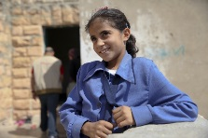 | T. Syrian Refugee Children  - View Voices of Syria’s Youth. Choose one of the themes of loss, homesickness, isolation and determination. Focusing on one of these themes, write a series of poems reflecting these feelings.  - With a partner, create and perform a conversation between a refugee and a new, Canadian friend who is trying to understand and support a young person with these feelings.  - Write a letter to the editor or editorial expressing an opinion about Syrian refugees.  - If possible, interview Syrian refugee children in your community. Make a report on this interview to your class.  - Write a poem about the feelings of a refugee modeled on Thoughts on Silence.  Thoughts on Silence  What am I doing here  Among these strange people  Sitting in these funny desks  Staring at this paper!  Oh yes, I am in school.  These people are my classmates.  Though they chatter all the time  They are silent now.  Now I can think.  I see a bird flying high in the air.  Maybe it is flying south.  My heart leaps with the bird  Taking a message to my mother.  My mind is heavy, thinking something sad has  Happened at home.  But the birds are singing  Everything is all right.  The breeze has whispered something in my ear.  I hope it whispers the same joyous words to my people.  I get lonely for my family and I especially miss my mother.  But I shall see them all soon.  When we meet we won’t even touch hands  But our hearts will leap for joy  And in our minds we will be glad.  Source: Steerling, Mary Jane. published in Hogan, Homer. (1972) Listen! Songs and Poems of Canada. Agincourt: Methuen.
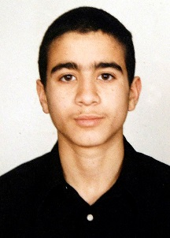 | - Omar Khadr  - View the 44 minute film Omar Khadr, Out of the Shadows  - Or these shorter films:  - The 1:36 minute trailer for the film, Guantanamo’s Child  - The 13 minute video shown on Democracy Now  - The 15 minute CBC video: Omar Khadr: His Side of the Story  - Write a song or poem about Khadr’s return to freedom.  - Read this fact sheet  - Write a series of diary entries from the point of view of Omar Khadr at several points in his life.  - Stage a debate: Be it resolved that Omar Khadr should not have been imprisoned in Gauntanamo Bay.  - Write a letter to the editor or editorial expressing an opinion about Omar Khadr’s case.  - View the film 27 minute film, Guantanamo: Blacked Out Bay  - Write a report on what you learned about the facility, the treatment of the prisoners, and the challenges faced by reporters who visit.

