Focus on Refugees and Immigrants in WAR IN MY LIFE

Read the poem Home by Warsan Shire:

Home, by Warsan Shire

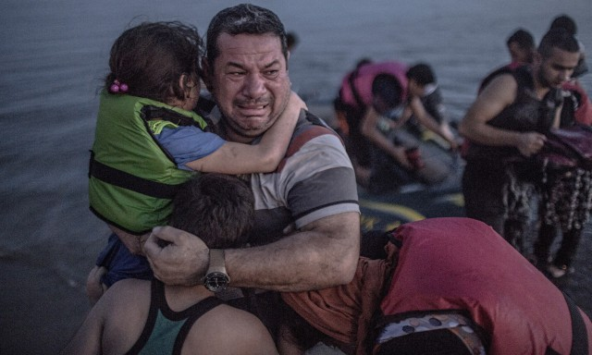
no one leaves home unless
home is the mouth of a shark.
you only run for the border
when you see the whole city
running as well
your neighbours running faster
than you, the boy you went to school with
who kissed you dizzy behind
the old tin factory is
holding a gun bigger than his body,
you only leave home
when home won’t let you stay.
no one would leave home unless home
chased you, fire under feet,
hot blood in your belly.
it’s not something you ever thought about
doing, and so when you did –
you carried the anthem under your breath,
waiting until the airport toilet
to tear up the passport and swallow,
each mouthful of paper making it clear that
you would not be going back.
you have to understand,
no one puts their children in a boat
unless the water is safer than the land.
who would choose to spend days
and nights in the stomach of a truck
unless the miles travelled
meant something more than journey.
no one would choose to crawl under fences,
be beaten until your shadow leaves you,
raped, then drowned, forced to the bottom of
the boat because you are darker, be sold,
starved, shot at the border like a sick animal,
be pitied, lose your name, lose your family,
make a refugee camp a home for a year or two or ten,
stripped and searched, find prison everywhere
and if you survive
and you are greeted on the other side with
go home blacks, refugees
dirty immigrants, asylum seekers
sucking our country dry of milk,
dark, with their hands out
smell strange, savage –
look what they’ve done to their own countries,
what will they do to ours?
the dirty looks in the street
softer than a limb torn off,
the indignity of everyday life
more tender than fourteen men who
look like your father, between
your legs, insults easier to swallow
than rubble, than your child’s body
in pieces – for now, forget about pride
your survival is more important.
i want to go home,
but home is the mouth of a shark
home is the barrel of the gun
and no one would leave home
unless home chased you to the shore
unless home tells you to
leave what you could not behind,
even if it was human.
no one leaves home until home
is a damp voice in your ear saying
leave, run now, i don’t know what
i’ve become.
You can listen to this poem as read by the author.

Look at the accompanying photos.
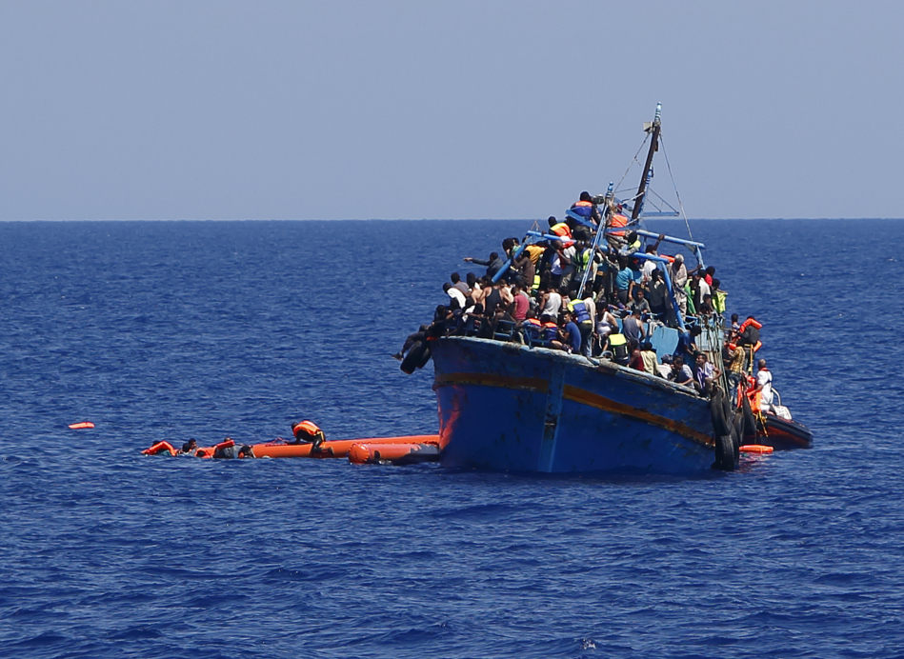

A group of 300 sub-Saharan Africans during a rescue operation by an Italian Financed Police vessel off the coast of Sicily, May 14, 2015. (Alessandro Bianchi/Reuters)
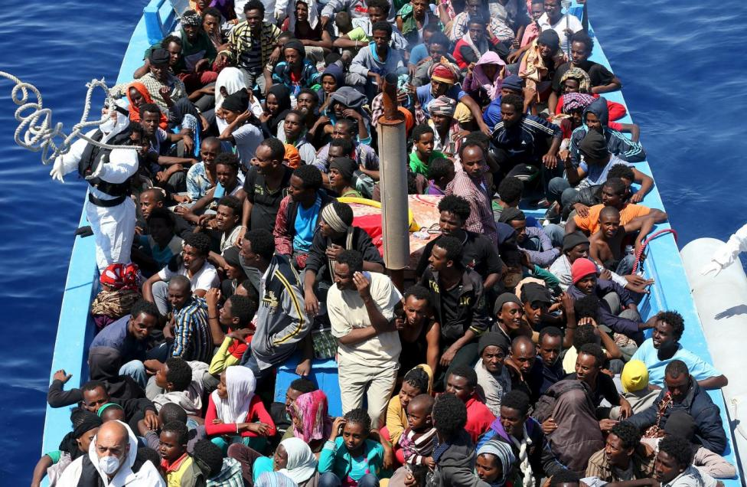

Migrants hang onto flotation tubes in the sea after jumping from an overloaded wooden boat during a rescue operation 16 kilometres off the coast of Libya. August 6, 2015. (Darrin Zammit Lupi/Reuters)

AFTER READING Home
CSI: COLOUR, SYMBOL, IMAGE
Think of the big ideas and themes in what you have just read. Choose a colour, a symbol and sketch an image that you think best captures the essence of the big ideas and themes.

Purpose:
- The CSI activity is useful to help students who are young or who are learning English to express what they have seen or learned.
- It encourages learners to make connections and think metaphorically after having experienced a powerful lesson.
- Using metaphors helps students link something new to something they already know by asking them to make connections and comparisons.
- The connections that students make will be highly personal and dependent on their experiences. To one student, black means a blank slate and possibilities. To another, blue may mean the same thing.
- CSI encourages metaphorical thinking.
Content:
- The content should be rich with a variety of interpretations and meaning: an essay, a chapter, a poem, a short film.
- It should not be too long or with too many competing ideas.
Steps:
- After reading the poem, make note of ideas that are important and insightful. This can be done individually or as a class.
- Choose a single colour which represents the core idea(s)
- Create a symbol (an image which represents something else: a dove = peace)
- Sketch an image which is like a photo or drawing of a scene. Drawing skills are not important; even if you use stick figures, capture your idea.
- Share the thinking. In pairs or small groups, students share their chosen colours, offering reasons. Do the same for symbols and images.
Tips:
- Vary the order. Start with an image if your students would find that easier.
- Students can complete the CSI activity on the computer by selecting a colour for the background, a symbol from those offered and an image from “Google images.”
Source: The CSI protocol is found in Church, M, Morrison, K. & Ritchhart, R. (2011). Making Thinking Visible: How to Promote Engagement, Understanding and Independence for All Learners. San Francisco: Jossey-Bass.

Watch the short NFB animation, From Far Away, Shira Avni & Serene El-haj Daoud, 2000, 6 min 39s

This short animation based on a book by Robert Munsch tells the story of Saoussan, a young girl struggling to adjust to life in Canada after being uprooted from her war-torn homeland. She has come to seek a quieter and safer life, although memories of war and death linger, memories that are awakened when the children at her new school prepare for a scary Hallowe’en. From Far Away speaks to the power within us all to adapt like Saoussan and to welcome a newcomer.
After watching the film:
- Write 3 or 4 diary entries from Sauossan’s perspective. Describe what her family fled, how she felt when she entered school, why Hallowe’en initially frightened her, and how she is feeling about her life 2 years later.
- Write 3 or 4 diary entries from the point of view of the teacher. Describe the arrival of new student and what you felt, the challenges faced by new comers, and what you as a teacher do to help them adapt.

Read the poem Select Samaritan
by Robert Finch
We think we might adopt two children and
The problem is to know which kind we want.
Not Canadians. Refugees, But they can't
Be Jewish. A couple of Spaniards would be grand
If they were fair. My husband hates dark hair.
Afraid they are mostly dark in any case.
Germans would do, we don't care about the race.
Except Chinese, must draw the line somewhere.
So would you let us know as soon as you could
What sort's available? We have a car
And would be glad to come and look them over
Whatever time you say. Poles might be good.
Of the right type. Fussy? Perhaps we are
But any kids we take will be in clover.

Source: Finch, Robert. Poems. Toronto: Oxford University Press, 1946
This volume was awarded the Governor General’s Literary Award for Poetry.

After reading the poem, imagine that you are the person to whom the speaker was addressing her comments. It is your job to write a short report on the interview and to make recommendations as to whether or not the adoption process should proceed.

- Write the report and make the recommendations that you feel are appropriate in this case.

Read three articles from The Globe and Mail about the refugee experience.

Crossings is an intimate, week-long series in The Globe and Mail about three young people who made difficult journeys to Canada from Hungary, Iraq and Syria begins with a look at how they are coping in body and spirit.
Far From Home, But Traditions Kept Close To The Heart
Name: Nancy Solakian Age: 19 Home country: Syria

New life comes with fears of illness for Hungarian refugees in Canada
Being granted full health coverage alleviated ‘a lot of stress’ for this Roma newcomer and his family.
Name: Laszlo Sarkozi Age: 16 Home country: Hungary

Refugee sponsorship program a chance to turn generosity into happiness

Name: Elizabeth Dunn, Psychology Professsor at the University Of British Columbia Sponsor of Syrian Refugees

After reading:
- From the point of view of Nancy, write a poem or a diary entry about what Armenian music means to her.
- From the point of view of Laslo, write a poem or diary entry.

Listen to the CBC audio program, No Way Home: Children and the Refugee Crisis from The Current – Nov. 2, 2015 1 hour, 15 mins.

After listening, choose one of the featured interviewees:

- Rebecca Canales from El Salvador
  - Write a diary based on this 7 year old’s experience
- Needs Centre in Winnipeg
  - Create a poster or flyer or webpage explaining the services of this centre
- Robin from Eritrea, who was expected to serve in the mandatory service; at 17 fled to Khartoum, Sudan, and is now a refugee in Canada.
  - Create 3 pages from a graphic short story or a storyboard for a film
- Bennie from Afghanistan attended a youth conference in the U.S. and fled to Niagara Falls, Canada
  - Write a monologue about Bennie’s need to flee and his escape over the border
  - Write a news article on Bennie’s experience with Matthew House in Toronto.
Other stories in this segment:
- Dalil, refugee from the DRC
- Greece holds unaccompanied refugee children behind bars
- Child refugees working on the streets in Beirut, possibly exploited by families
- Refugee Children are more vulnerable in winter
- Unaccompanied refugees disappearing in Europe

- Choose one of these segments and
  - Write a monologue, diary entry or poem
  - Write a letter to the editor or editorial
  - Write a news article
  - Write a report written from the point of view of a youth worker who is supporting refugee youth living alone in Canada

Watch the 10 minute NFB documentary, Suffer Little Children (Sydney Newman, 1945, 10 mins.)
At the end of World War II, there were 60 million sick and starving children in Europe. The United Nations Relief and Rehabilitation Administration (UNRRA) undertook to provide food, clothing, shelter, medical care, education and sympathetic attention to these terrorized victims of war.
- Who was the intended audience and what was the purpose of this film?
- Did anything surprise you in this film?

