**Ticket Out The Door**

I’ve learned this about war:

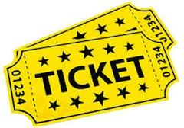

**Ticket Out The Door**

I’ve learned this about war:



**Ticket Out The Door**

I’ve learned this about war:



**Ticket Out The Door**

I’ve learned this about war:

