**Ticket Out The Door**

How important is it to protect

children from war?

* Very
* Children are not more important than adults
* Not Important

Because:

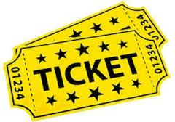

**Ticket Out The Door**

How important is it to protect

children from war?

* Very
* Children are not more important than adults
* Not Important

Because:



**Ticket Out The Door**

How important is it to protect

children from war?

* Very
* Children are not more important than adults
* Not Important

Because:



**Ticket Out The Door**

How important is it to protect

children from war?

* Very
* Children are not more important than adults
* Not Important

Because:

